Founded in 1952 by Arthur Landon, an English businessman

who travelled the world in search of the perfect balance of

comfort, personality, and convenience.

Each Landon Hotel reflects the color, flavor, and personality of the local neighborhood, giving visitors an authentic travel experience that honors the history and culture of the region.

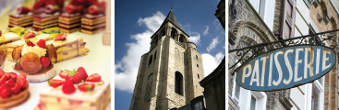

With 400 neighborhoods in 20 countries, we go out of our way to make you feel at home.

### THE LANDON HOTEL

### LATIN QUARTER, PARIS

261 Rue Saint-Séverin,

75005 Paris, France

PHONE 01 42 517 85

FAX 01 42 517 95

EMAIL [info@landonhotel.com](mailto:info@landonhotel.com)

WEBSITE [www.landonhotel.com](http://www.landonhotel.com)

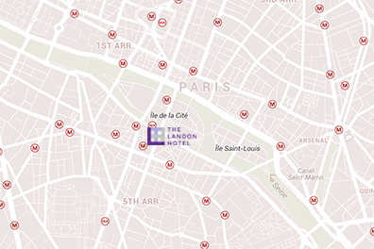

Facilities

**35 Elegant Rooms**

**3 Executive Suites**

**4 Pet-Friendly Rooms**

**Penthouse**

**Underground Jazz Club**

**Coffee Bar**

**Bakery**

Amenities

**Wireless Internet**

**Breakfast Pastries**

**Daily Maid Service**

**Laundry & Dry Cleaning Service**

**Concierge Service**

**Express Checkout**

**24-Hour Security**

Local Sights

**Place St. Michel**

**Paris Panthéon**

**Cluny Museum**

**Church of St. Séverin**

**Luxembourg Gardens**

**Shakespeare & Co Bookstore**

**Sorbonne University**

The Bohemian Landon

Since the Middle Ages, the Latin Quarter has been a neighborhood of artists, writers, and intellects, and the **Latin Quarter Landon** exudes this in every brick of its building.

It’s a common experience that a tourist finds himself derailed from an ordinary day of tourism, to sit in the vintage reading room of the **Latin Quarter Landon** and debate politics, discuss literature, or recite poetry with natives, while sipping coffee amongst the hotel’s sizable book stacks.

When night falls, locals head to the **Underground Jazz Club**, in the hotel basement, to hear the most celebrated voices in jazz, both long-standing and up-and-coming.

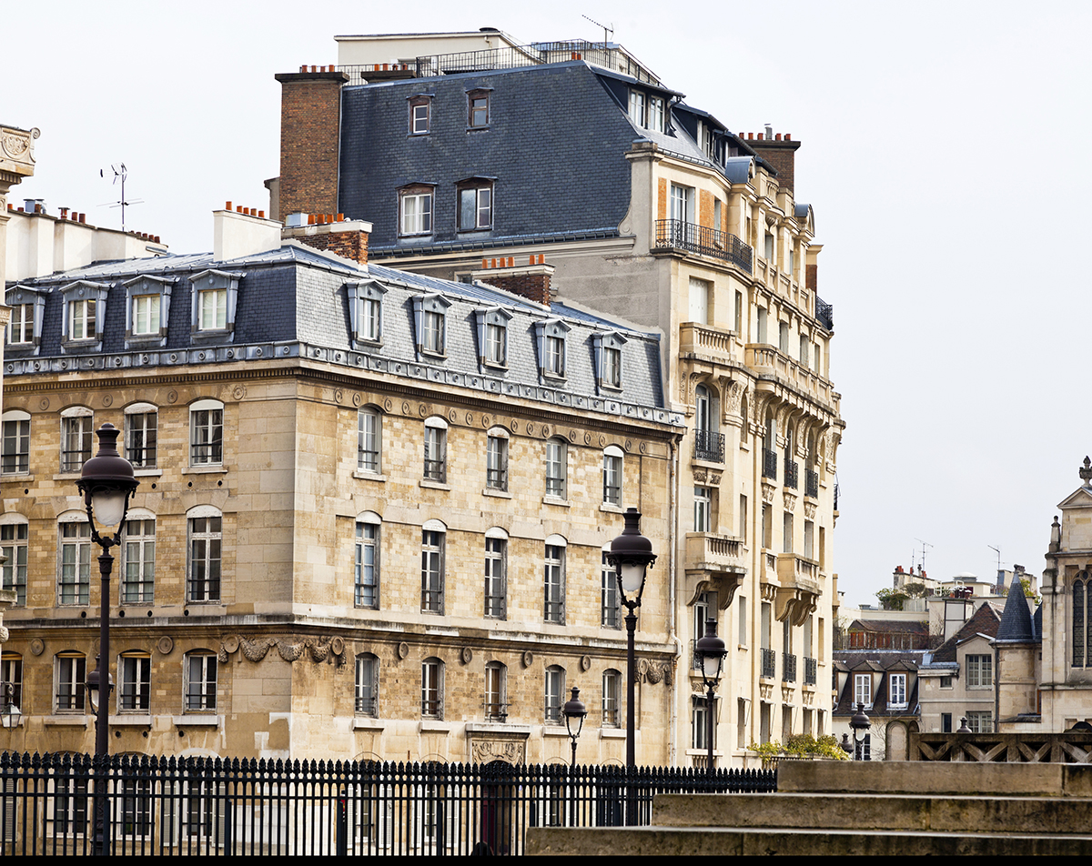

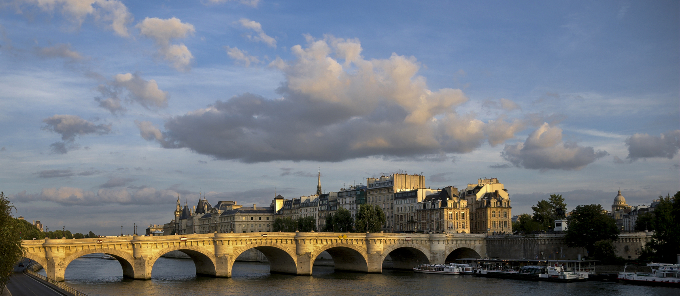

## A neighborhood of intellect, art, and culture

The Latin Quarter is considered the intellectual center of Paris, and was named at a time when all students and professors of the Sorbonne University spoke Latin. Today it’s home to a dizzying array of intellectual venues including bookstores, schools, churches, and publishing houses. A scattering of Roman ruins, including the Pantheon, and other historical architecture and monuments, including the Fontaine Saint-Michel, also characterize the Latin Quarter.

Some of the delights of the region include gourmet food and wine tastings, as well as tours of favorite haunts frequented by famous writers and other intellects, including Ernest Hemingway, Oscar Wilde, and Gertrude Stein, to name a few. Walking tours of historical churches, some dating back as early as the 12th Century, including the St. Germaine des Prés Abbey and the Church of the Cordelier’s, are also aplenty. In addition, the Cordelier’s Monastery, adjacent to the church, houses the Museum of Popular Art and Tradition, a must-see for anyone interested in the art and culture of the region.

If you’d prefer a bit of non-intellectual pursuit, there is no shortage of charming boutiques where you can purchase treasures from this fascinating and culturally-rich region. And all of this is easily within walking distance from the **Latin Quarter Landon.**

